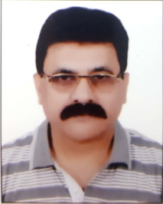
CURRICULAM VITAE
Dr. SHUEB AHMAD E-mail: ahmad.shueb@yahoo.in
Associate Professor Mobile : +919450018586
Shia P.G. College,
Lucknow – 226020,
Res. Add- 2/1-2 Professors colony,
Radha gram,
Thakurganj, Lucknow 226003

Educational Qualification

Ph.D. | Department Of Commerce, Saket College, Dr. Ram Manohar Lohia Avadh University, Faizabad, Year- 2012.  Topic-“Liberalisation and Life Insurance Entrepreneurship in India (with special study of I.R.D.A’s Regulations)” .
M. Com. | Faculty of Commerce, Rohilkhand University, Year-1983

Present Position (Associate Professor) Incharge- Faculty Of Commerce
Shia P.G. College, Sitapur Road, Lucknow, 20

Teaching Experience in Post Graduate level

Since 2006 till date

Teaching Experience in Under-Graduate level

Since 23 july, 1984

List of Publications

“Arth Vyavastha ke andhere-ujale avam kar-padhti”- Sahkarita Magazine.

“Scientific Tax-Planning”- Sahkarita Magazine.

“Bharat me Videshi Sahayta”- Sahkarita Magazine.

“Tax Evasion :A mighty lever of the parallel economy”- Radiance (weekly) Delhi.

“Shikshit Berozgari aur arth-tantra” - Sahkarita Magazine.

“Krishi Vikas aur nayi Yojanaye: Sarthakta kahaN tak”- Sahkarita Magazine.

Book Published

Indo-Japan Economic Relations During Planning Period. - (Year-1993)

